PROJECT DOCUMENTATION
SignMee — AI-Based ASL & Hand Gesture Recognition App
Real-time American Sign Language and hand-gesture translation in the browser, built with React, TypeScript, and Google's MediaPipe Hand Landmarker.
Repository: https://github.com/M-Jash/sign-mee
Live App: https://sign-mee-zeta.vercel.app
Prepared: July 2026

1. Project Overview
SignMee is a web-based computer-vision application that translates American Sign Language (ASL) alphabet signs and common hand gestures into text in real time, using only a browser and a webcam — no server-side inference or app install required.
The system operates in two selectable modes:
- ASL Alphabet Mode — recognizes 24 static letters of the ASL fingerspelling alphabet (A–Y, excluding J and Z, which require motion).
- Gesture Mode — recognizes 8 common hand gestures: Open Palm, Fist, Thumbs Up, Peace, Pointing, Rock On, Call Me, and OK Sign.
Key characteristics of the implementation:
- Runs entirely client-side in the browser (no images or video are uploaded to a server).
- Uses Google's pre-trained MediaPipe HandLandmarker model to extract 21 hand keypoints per frame — no custom model training was required.
- Classification is performed by a hand-authored, geometry-based rule engine (finger curl angles, inter-finger spread, and landmark distances), not a trained neural network.
- A 6-frame stability/majority-vote filter is applied before a result is shown, to avoid flicker between similar hand shapes.
Attribute | Detail
Frontend | React 18 + TypeScript, built with Vite
Styling | Tailwind CSS + PostCSS
Computer Vision | @mediapipe/tasks-vision — HandLandmarker (GPU delegate)
Classification | Custom rule-based scoring (aslClassifier.ts, gestureClassifier.ts)
Linting | ESLint (typescript-eslint)
Backend / Auth | @supabase/supabase-js (present in dependencies)
Hosting | Vercel

2. Dataset Files
SignMee does not train its own classifier on a labeled image dataset. Instead of a CNN trained on thousands of hand images, it reuses Google's pre-trained MediaPipe Hand Landmarker to locate 21 hand keypoints per frame, and then applies deterministic geometric rules (finger-joint angles and landmark distances) to map those keypoints to an ASL letter or gesture. Because of this, there is no custom dataset shipped with, or required by, the repository — this section documents the input data source used instead.

2.1 Pre-trained Landmark Model (used at runtime)
MediaPipe HandLandmarker task file: https://storage.googleapis.com/mediapipe-models/hand_landmarker/hand_landmarker/float16/1/hand_landmarker.task
MediaPipe Hand Landmarker documentation: https://ai.google.dev/edge/mediapipe/solutions/vision/hand_landmarker
This model is downloaded by the browser at runtime (see the WASM_BASE / MODEL_URL constants in useHandGestureRecognition.ts) and outputs 21 (x, y, z) landmarks per detected hand, per frame.

2.2 Reference Dataset Named in Source Comments
The header comment in aslClassifier.ts notes that its feature space (normalized landmark distances, joint curl angles, inter-finger spreads) mirrors the structure of a public Kaggle resource named "ASL Gesture Dataset Using MediaPipe." No image or landmark files from that resource are bundled in this repository — it is cited only as a design reference for which landmark-derived features are informative for static ASL classification. A general, verified public alternative covering the same MediaPipe 21-point feature space is linked below for reference.
Kaggle — American Sign Language A-Z Dataset + Hand Landmarks: https://www.kaggle.com/datasets/srisahithis/american-sign-language-a-z-dataset-hand-landmarks
Note: the exact Kaggle listing referenced in the source comment could not be independently located at the time of writing this documentation; it may have been renamed, removed, or was referenced informally by the original author. Report this to the project owner if an authoritative link is available.

3. Dataset / Notebook
SignMee has no Jupyter/Python training notebook, because no offline model training step exists in this project — classification happens live, in TypeScript, in the browser. The logical equivalent of a "training notebook" here is the hand-authored feature-engineering and rule-scoring logic implemented directly in source:
- src/aslClassifier.ts — feature extraction + per-letter scoring rules for the ASL alphabet.
- src/gestureClassifier.ts — finger-state extraction + scoring rules for the 8 general gestures.
If a formal exploratory notebook is required for submission, the recommended approach is to record a short Python/Jupyter notebook that loads MediaPipe's HandLandmarker on sample images and visualizes the same 21-point landmark features referenced by aslClassifier.ts (joint curl, finger spread, tip-to-thumb distance) — mirroring the logic already implemented in production TypeScript. This keeps the notebook and the shipped app consistent.

4. Code
Full source: https://github.com/M-Jash/sign-mee

4.1 Project Structure
src/
├── components/
│ ├── CameraToggle.tsx # Controls video stream access
│ ├── GestureReference.tsx # Visual guide for users
│ ├── Header.tsx # Main navigation & branding
│ ├── ResultPanel.tsx # Displays translated text outputs
│ ├── StatusBadge.tsx # Real-time connection/tracking state
│ └── VideoWorkspace.tsx # Video layout container
├── aslClassifier.ts # ASL letter translation rules
├── gestureClassifier.ts # Core gesture matching logic
├── useHandGestureRecognition.ts# React hook managing model state & frames
├── types.ts # TypeScript interfaces and declarations
└── main.tsx # Application entry point

4.2 Model Loading & Detection Loop (useHandGestureRecognition.ts)
Loads the MediaPipe model, opens the webcam, and runs detection on every animation frame:
const WASM_BASE = 'https://cdn.jsdelivr.net/npm/@mediapipe/tasks-vision@0.10.18/wasm';
const MODEL_URL =
'https://storage.googleapis.com/mediapipe-models/hand_landmarker/
hand_landmarker/float16/1/hand_landmarker.task';

const filesetResolver = await FilesetResolver.forVisionTasks(WASM_BASE);
const landmarker = await HandLandmarker.createFromOptions(filesetResolver, {
baseOptions: { modelAssetPath: MODEL_URL, delegate: 'GPU' },
runningMode: 'VIDEO',
numHands: 1,
minHandDetectionConfidence: 0.5,
minHandPresenceConfidence: 0.5,
minTrackingConfidence: 0.5,
});

// Inside the per-frame loop:
const results = landmarker.detectForVideo(video, performance.now());
const detected = detectionMode === 'asl'
? classifyASL(hand, handedness)
: classifyGesture(hand, handedness);

4.3 ASL Feature Extraction (aslClassifier.ts)
Each of the 21 landmarks is converted into geometric features — joint curl (0 = straight, 1 = folded), finger direction, and thumb-to-fingertip distances, all normalized by palm size:
function jointCurl(lm: Landmark[], a: number, b: number, c: number): number {
const v1x = lm[b].x - lm[a].x, v1y = lm[b].y - lm[a].y;
const v2x = lm[c].x - lm[b].x, v2y = lm[c].y - lm[b].y;
return angleBetween(v1x, v1y, v2x, v2y) / 180;
}

// Example rule — letter 'X': index finger hooked, others curled
add('X', 'Index finger hooked', score([
[f.iC > 0.3 && f.iC < 0.7, 2],
[curled(f.mC), 1], [curled(f.rC), 1], [curled(f.pC), 1],
[!f.tExt, 0.5],
]));

// Best-scoring candidate wins; confidence is derived from its score
const confidence = Math.round(Math.min(99, 72 + best.score * 27));
Every one of the 24 supported letters (A–I, K–Y) is defined the same way: a weighted checklist of geometric conditions, scored 0–1, with the highest-scoring letter reported above a 0.6 acceptance threshold.

4.4 Gesture Classification (gestureClassifier.ts)
function isFingerExtended(landmarks: Landmark[], finger: FingerIndex): boolean {
const tipToWrist = distance(tip, wrist);
const pipToWrist = distance(pip, wrist);
const mcpToWrist = distance(mcp, wrist);
return tipToWrist > pipToWrist && tipToWrist > mcpToWrist * 1.1;
}

// Each gesture is a target on/off pattern across [thumb,index,middle,ring,pinky]
add({ name: 'Peace', emoji: 'V-sign', ... }, [false, true, true, false, false]);
add({ name: 'Rock On', emoji: 'horns', ... }, [false, true, false, false, true]);

4.5 Stabilization Logic
To prevent the displayed letter/gesture from flickering between adjacent frames, results are collected over a rolling 6-frame window; a result only 'locks in' once it wins at least 60% of that window (STABILITY_FRAMES = 6, STABILITY_THRESHOLD = 0.6).

5. Graphs & Charts
As SignMee uses a deterministic rule engine rather than a trained model, there are no training/validation loss curves. The charts below instead document the system's data-flow architecture and the behavior of its confidence-scoring functions.

5.1 Recognition Pipeline
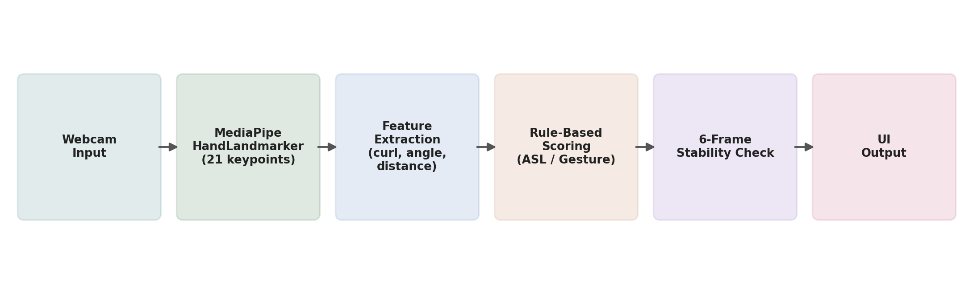
Figure 1. End-to-end data flow, from webcam frame to displayed result.

5.2 Confidence Score Curves
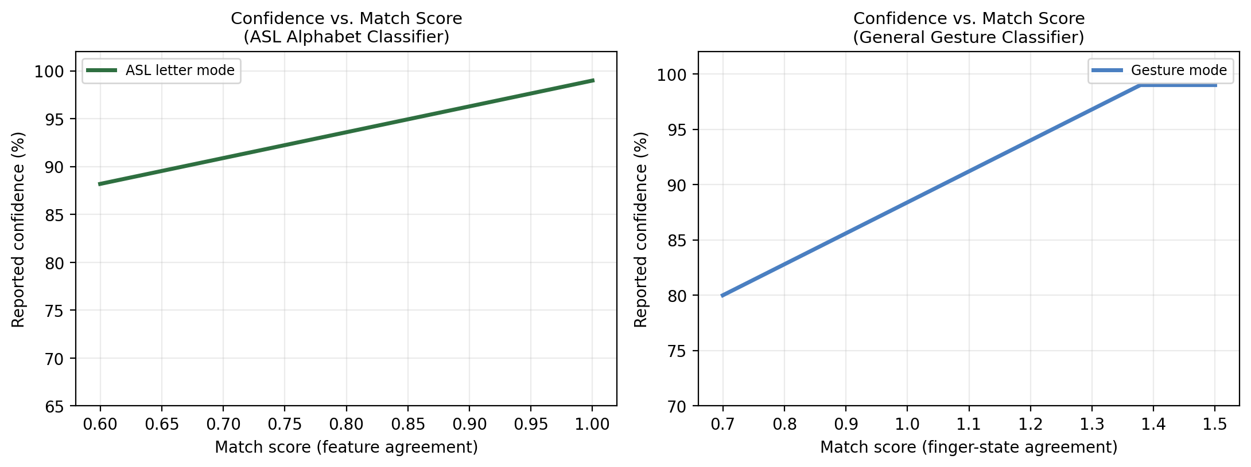
Figure 2. How each classifier's internal match score is mapped to a reported confidence percentage.

5.3 ASL Alphabet Coverage
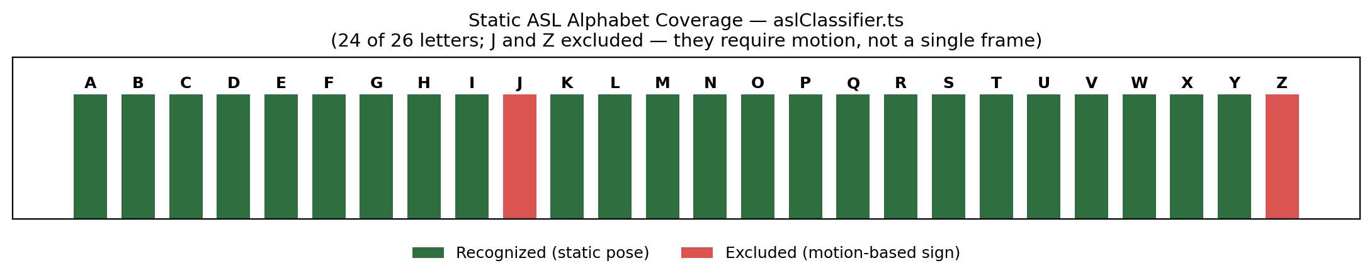
Figure 3. 24 of 26 ASL letters are supported; J and Z are excluded because they require in-air motion, not a single static hand pose.

6. Output Screenshots
Live detection running in the browser (Bolt preview), correctly classifying the ASL letter "X" with hand landmarks overlaid on the video feed:
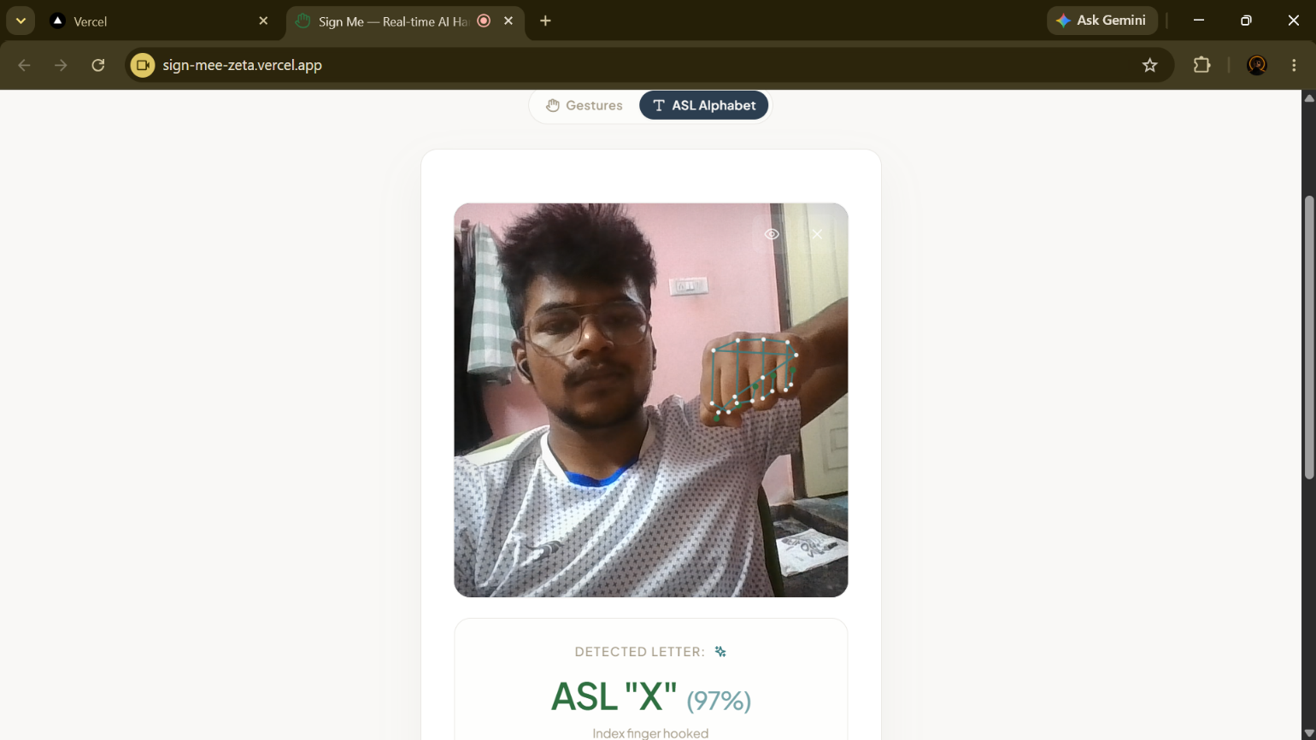
Figure 4. ASL Alphabet Mode — detected letter "X" at 97% confidence, with the reasoning ("Index finger hooked") shown beneath the result.

7. Notes & Limitations
- Single-hand detection only (numHands: 1); multi-hand signs are not supported.
- Letters J and Z are unsupported because they require motion trajectories, not a static pose.
- Because classification is rule-based rather than learned from data, accuracy depends on manually tuned thresholds and may vary with hand size, camera angle, and lighting.
- All processing is local to the browser; no video or images leave the device.

